CSCU9N5 Assignment GIMP Tutorial Website

Student ID Number - 2636157

University of Stirling

Contents

1. Introduction 3

2. Description 3

2.1. What is the Website? 3

2.2. Target Audience 4

2.2.1. Two Specific Personas 4

2.2.1.1. Persona One 4

2.2.1.2. Persona Two 4

2.2.2. Prototype Delivery 4

3. Design Details 5

3.1. Design Decisions 5

3.1.1. Schneiderman’s Golden Rules 5

3.2. Wireframes, Content and Media Elements 6

3.2.1. Homepage 6

3.2.2. Tutorials Page 7

3.2.3. Hints and Tool Tips Page 7

3.2.4. Shortcuts Page 7

3.2.1. Beginners Tutorials Page 7

3.4. Moqups Images 8

3.4.1. Homepage 8

3.4.2. Tutorials Page 9

3.4.3. Hints and Tool Tips Page 9

3.4.2. Shortcuts Page 9

3.4.2. Beginners Tutorials Page 9

3.5. Navigation Map 10

3.6. Persona Scenarios 10

3.6.1. Scenario One 10

3.6.2. Scenario Two 11

3.7. Style Guild 12

3.7.1. Colour Scheme 12

3.7.2. Font Choices 12

3.7. Prototype Description 12

3.7.1. Included Features and Elements 13

3.7.1. Features and Elements not Included 13

4. Testing 13

4.1. Usability Test 14

4.2. Test Plan 14

4.3. Test Runs 14

# 1. Introduction

For my assignment I have been tasked with designing and developing a prototype web-based application from a choice of provided topics, I have decided to go with option two: an introduction to a software package. The software package I am going to be creating my website around is GIMP. GIMP is a GNU Image Manipulation Program, similar to Paint.net and Photoshop. All my files/pages for the website will be saved with the file format of .html and the index of the wenkite will be named under “**index.html**” inside of the folder “GIMP Help Site”.

When designing the prototype, I will be using and following Schneiderman’s Golden Rules to help me with coming up with designs that are within the rules. Using these rules will help me design and produce a good design that will show consistency and a good use of design practice and skills.

Throughout the following sections I plan on going into great detail about what the website is about and my justification of why I have chosen a specific design and why I have chosen to implement certain features. I will also be talking about the target audience along with creating two distinct personas and how the website will be aimed towards them in different aspects. I will be using PACT (People, Activities, Context and Technologies) structure to analyse and go into detail with my two created personas which are found in section: *2.2.1. Two Specific Personas*. These will be used to see how effective my design is compared to the two different personalities and knowledge.

# 2. Description

## 2.1. What is the Website?

My concept for my prototype web-based application is a website that provides tutorials, hints and shortcuts for users that want to learn how to use GIMP. For the purpose of the prototype, I will be creating multiple html pages that will all be linked to each other, in future, the website will use scene switching with the use of php instead when necessary, preventing the duplication of pages that only have minor changes.

My plan is to create seven individual pages for the prototype, in future development I may plan on developing more but for the prototype I feel this is a sufficient amount about to represent how each page will look and operate. The website will include tutorials/walkthroughs of three different difficulties (beginner, intermediate and complex) that will walk the users through the process of different tasks step by step with text and images. Only the beginner’s tutorials will include a completed tutorial in the prototype stage, I have done this to show what a tutorial will look like and how it will be laid out in finished website. Shortcuts will also be displayed in tables ordered by the type of shortcut, this will be held on the shortcuts page. I will also be providing hints and tool tips for the user on the hints and tool tips page, this page will not be fully complete in the prototype and will be worked in later development after the prototype has been produced. I plan to make sure that the website style and layout is very simple to help users navigate and understand the website.

## 2.2. Target Audience

The target audience that I will be aiming my website towards will users that are in field of computing or just starting to use and understand computing, this can be from young students just starting to use photo editing software to an experienced computer user that needs to check online from time to time for reminders of how to do certain things. The age range I would set would be between 15 to 50 but the website will suitable for anyone at any age and any experience with computing and photo editing. For the understanding of how my design will be flexible to different types of user, I am going to create two distinct personas. I am going to try and make both personas as different as possible. You can find both these personas in section *2.2.1. Two Specific Personas*.

### 2.2.1. Two Specific Personas

#### 2.2.1.1. Persona One

Smithy  
The first persona is a 45-year-old man named Smithy who works as a police officer at his local police station. He is currently married and has two children who are aged nine and thirteen. Smithy often has to help his children with homework and projects, this results in him going online to search help and solutions to some of the problems. The only problem with doing this is that Smithy does not have a great understanding of computers and barely used one until now. He is someone that likes to get things done as soon as possible, which he emphasises to his children with homework. Smithy is a very outgoing person who gets along with everyone and enjoys attending the football every weekend with his children.

#### 2.2.1.2. Persona Two

Marco  
The second persona is 19-year-old student named Marco who is currently in his third year of studying computing science at university. Marco has studied computing throughout high school and his previous years at university giving him a great understanding of computing. Being young, he took advantage of all new rising technologies throughout his education which resulted in him growing fonder and gaining a greater passion for computing with new technologies. Marco enjoys socializing and going out with friends along with staying home and playing video games and is currently unemployed due to his university studies. He also likes to edit and create pictures and image in his free time whenever he’s not studying or playing video games.

Marco prefers to work along and prefers not to ask for help, but instead he tries to find his own solution to his problems, whether that is researching via reading a book or searching for a solution online. He currently lives on campus in student accommodation with his roommates Jadon who studies sports management and Roman who studies music. Marco enjoys his current course but can be a bit lazy and leaves a lot of his assignments last minute.

### 2.2.2. Prototype Delivery

I plan to have the website prototype completed and submitted before 4:00pm on November 11th. I will be placing all required html and media files along with the required report into a folder, which will then be zipped to produce a .zip folder that will then be uploaded onto Canvas. I will also being including my test plan, runs and questionnaires feedback in external files as evidence of my testing.

# 3. Design Details

My website has been designed and developed round Schneiderman’s Golden Rules as I previously stated in section: *1. Introduction*. I will be justifying my design choices that go along with the Golden Rules to provide consistency throughout the website and good design structure.

I will discuss and going into detail about the navigation and layout of the website in the later section: *3.5. Navigation Map*. I will also talk about the use of features and styles later in the section: 3.1. Design Decisions where I will be going through each Golden Rule (section: *3.1.1. Schneiderman’s Golden Rules*) that applies to my website that I have followed and discussing how I have followed these rules with references to the web site. I will also be covering the design features and style in the section: *3.2. Wireframes* with breakdowns of each induvial page.

## 3.1. Design Decisions

## 3.1.1. Schneiderman’s Golden Rules

I am going to be discussing and justify my reasoning with my design according to the Schneiderman’s Golden Rules. I will be discussing all rules that relevant to the prototype and also my plans for further development for rules that not currently relevant and cannot be referred to. I carried further reached on the eight rules and found a website that I have followed to help with carrying out the rules. The website can be found in the final section of information sourced.

1. Consistency  
My plan from the vert start was to make the website consistent as possible and I feel I have achieved this at a great level. I have ensured that the menus are accessible on every page of the site and that the layout and design is the same with the structure and flow of information that is being displayed. I have also kept the colour scheme/palette the same throughout the site with exceptions to certain features to encourage the user to focus on it.

2. Shortcuts  
Having every page linked to each other and access to the menus on every page, I have created multiple shortcuts for the user to access pages faster with a single link click, rather than having to search through multiple pages to find what they are looking for.

3. Informative Feedback  
Implementing an animation feature to my home page button allows users have the ability to mouse over the menu image at the top of the screen and have the image change to a home button. All the buttons and links shown on the website change the mouse icon when hovered over to indicate that an action is carried out when clicked.

4. Dialogue  
There are currently no features implemented into the prototype that follows this rule but in future, I plan on having multiple features that will display pop ups for user activities and notices.

5. Error Handling  
There are currently no features implemented into the prototype that are required to have error handling. My concept idea in the fully finished design would to have a sign in ability to allow users to login and post to a forum.

6. Permit Reversal of Actions  
With the ability of being able to access almost every page from the menu, the user can move freely throughout the website even they have selected the wrong page, giving them the ability to select the required page even when they are on the wrong page.

7. Support Internal Locus of Control  
When a user uses my website, I want them to feel like they are in control and have the ability to freely navigate through the website and how they want to navigate instead of having to follow a strict path to access something. My goal is to enable the user to use the website efferently, making it easy for them to use and understand. Having a simple layout and design allows the user to see what is being displayed clearly and understand where they can access, giving them the feeling of full control of the website when using it.

8. Reduce Short-Term Memory Load  
Keeping all my page consistent in design and layout, I have made sure that the users do not have to process a lot content at a time. Users will feel more comfortable with the simple layout and not too much information displayed at the one time, breaking up paragraphs of text with images helps the user understand the situation a lot clearer and they are also more likely to remember and understand what they have just read, rather than reading a wall of text.

## 3.2. Wireframes, Content and Media Elements

In this section I will discussing in detail about what each page is about along with the relevant wireframe. The wireframes I have created will show what each web page will look like and give me starting point for my design when to starting to create my website. With the wireframes that I have produces I have shown all content and media elements that are going to be implemented into the site, I will be discussing all implemented features in the below section. For a better picture of what the pages will look like with all the implemented feature are shown in section: *3.4. Moqups Images*.

### 3.2.1. Homepage

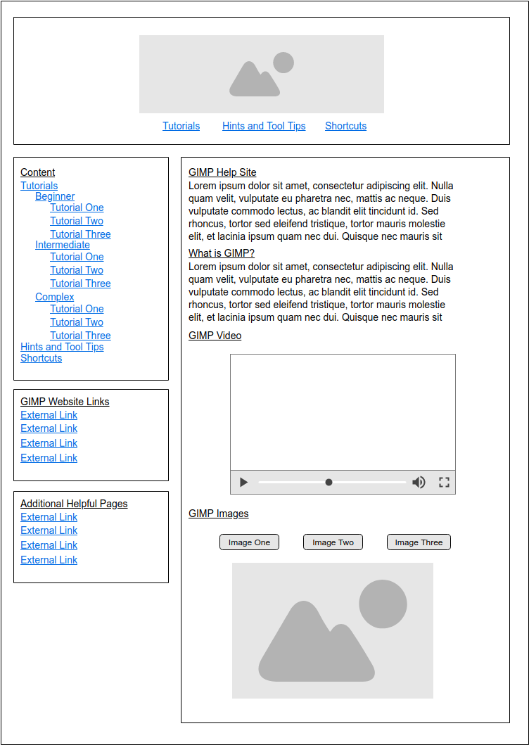

1

2

3

4

On all pages, there will be an image at the top of the page which will be the main logo of the website (The GIMP logo) but will also be used as a home button with the use of animation to change the image into a button (**1**). Another feature that will be included with all pages is the menu bar down the side of the page (**2**). This provides quicker navigation throughout the website rather than going back to the homage every time to select a new page. The homepage will also include several media elements such as an embedded video (**3**) and an image viewer (**4**) by using buttons with the use of JavaScript. The video will allow the user to have complete contain with all setting available at their disposal.

All pages have the palpability to be resized, all content will be resized relevant to the dimensions of the window in its current state.

### 3.2.2. Tutorials Page

The tutorial page will page will only have details about tutorials and multiple lists of links (**1**) according to the different difficulties available. Only the beginner’s tutorials will be accessible in the prototype version. I have chosen to do this because I feel as though it is a good example of what the other pages will look like in the finished version of the website.

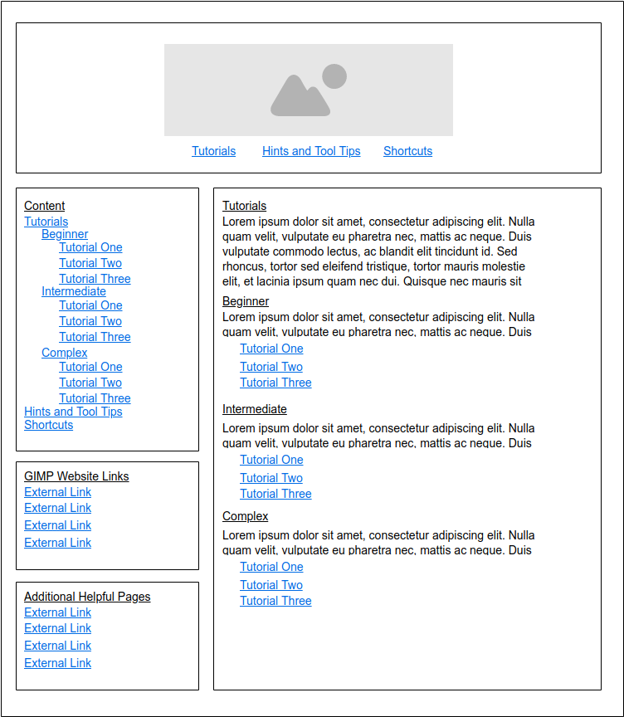

1

### 

### 3.2.3. Hints and Tool Tips Page

This is what the hints and tool tips will look like, it will include small lists of different helpful tips and hints (**1**) that the user can use to help understand and use GIMP a lot smoother. I have not currently finished this page; the prototype does have this page included but it will display a message stating that it has not been completed due to being in the prototype stage of development. I have not completed this page because I feel it is very easy to understand what will be displayed and how its content will be displayed compared to other pages on the site.

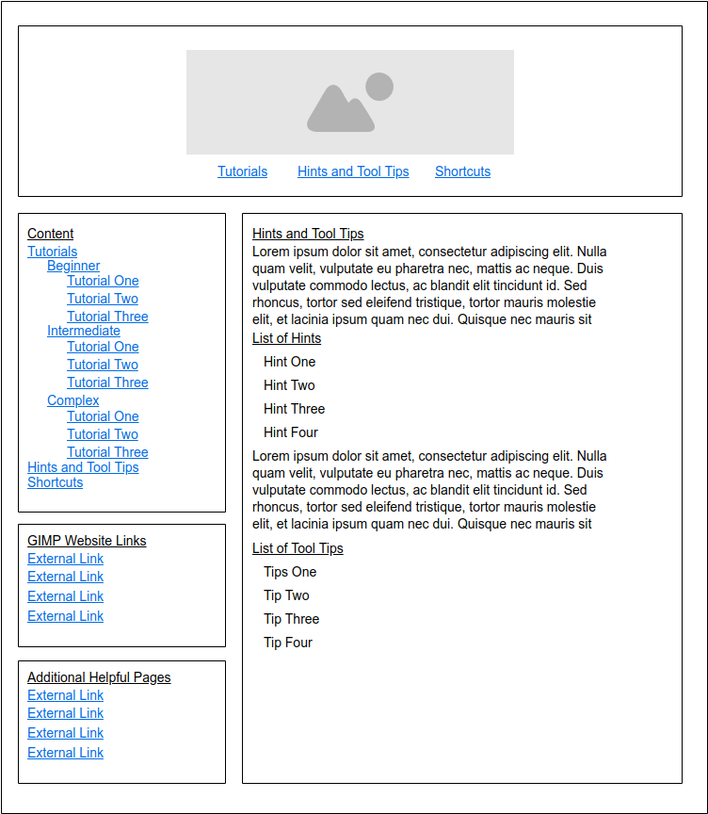

1

### 3.2.4. Shortcuts Page

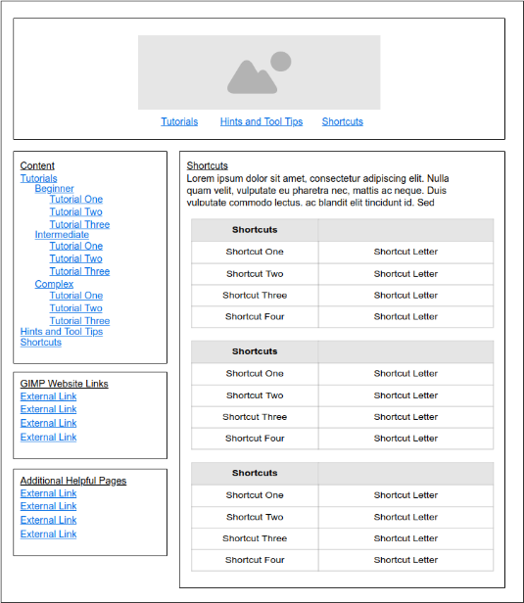

1

The shortcuts page will have a short paragraph of information stating what the page is about and also display several tables containing different types of shortcuts relevant to the heading (**1**).

### 3.2.1. Beginners Tutorials Page

This page is where the walkthroughs of tasks in GIMP is broken down into steps using text and images (**1**). The two other tutorial difficulties (intermediate and complex) pages have the same layout as this page with the relevant information, therefore I have only produced the one wireframe for all three. All tutorials for the specified difficulty are all displayed on the one page with links on tutorials page in the side menus linking to the required part of the page.

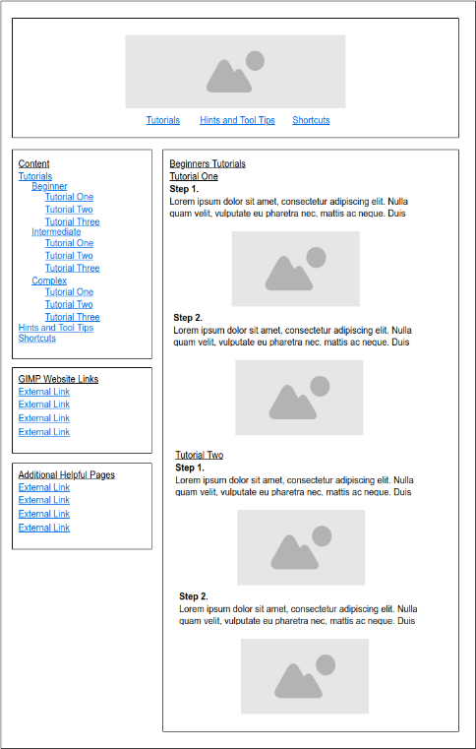

1

## 3.4. Moqups Images

I have used and built upon the wire frame in section: 3.2. Wireframes, Content and Media Elements to create Moqups images of what the site will look like with the using chosen colour scheme shown in section: *3.7.1. Colour Scheme*. I have kept colour blind/ users with sight disabilities in mind to try and keep a low number of colours to avoid any contrasting which may affect some users. Using blue as the main colour for the website means that it is very easy on the, creating a calming effect to each page. Using these colours means that it is less likely to distress any users as the colours do not clash and cause visual problems when looked at.

The moqups that I have produced show where all content and media elements will be used, I have tried to include some sort of content on each page and tried to keep it to small amounts to avoid overloading the page with content and information which could make it difficult to understand what is happening on the displayed screen.

### 3.4.1. Homepage

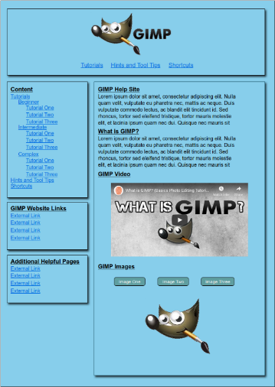Wireframe and breakdown of this page is found in section: *3.2.1. Homepage*.

### 3.4.2. Tutorials Page

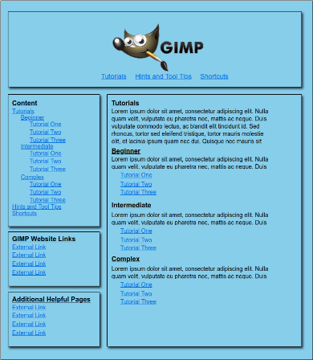Wireframe and breakdown of this page is found in section: *3.2.2. Tutorials Page*.

### 3.4.3. Hints and Tool Tips Page

Wireframe and breakdown of this page is found in section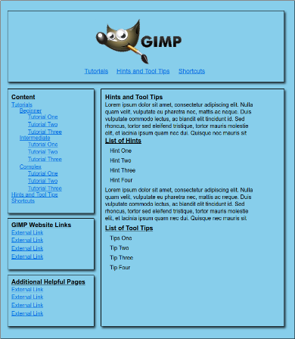: *3.2.3. Hints and Tool Tips Page*.

### 3.4.2. Shortcuts Page

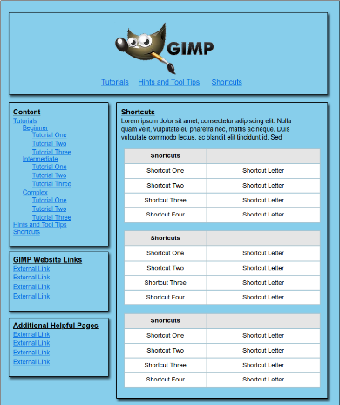Wireframe and breakdown of this page is found in section: *3.4.2. Shortcuts Page*.

### 3.4.2. Beginners Tutorials Page

Wireframe and breakdown of this page is found in section: *3.2.1. Beginners Tutorials Page*.

## 3.5. Navigation Map

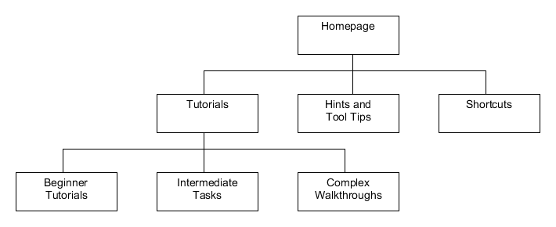I have created a navigation map of what the website will look like. The layout of the website is very basic, with all pages linking up to the homepage but are accessible throughout the via side menus which are demonstrated in the wireframes in section: *3.2. Wireframes, Content and Media Elements*. The Tutorials page will conation links to other pages which show tutorials according to the difficulty that the user has chosen. Hints and Tools Tips will show helpful hints and tips for the user to use and the Shortcuts will contain tables with different types of shortcuts that are available. The navigation map shows the basic layout and navigation of what the starting prototype will look like. I have kept it very simple and basic to make it easier to understand and navigate.

## 3.6. Persona Scenarios

I will be creating two concreate scenarios for my two personas (they can be found in section: *2.2.1. Two Specific Personas*) carryout tasks on the website. I have carried research on the P-A-C-T framework and have dedicated the two scenarios around it. The sources I used to research this topic can be found at the end on the report in identification of information sourced.

### 3.6.1. Scenario One

The first scenario that will be created revolves around persona number one (*2.2.1.1. Persona One*) - Smithy.

One of his children have recently received a school project, with the project requiring a produced report. With the report specification, it has stated that it requires and number of images to go along with text. A list of potential online resources and software has also been handed out along with the specification to help with the report. Smithy is very determined to help and has decide to pick a software for editing and creating images from the list, this being GIMP. Not know anything about GIMP, he decides to look online and research on what it is and how to use it, thus finding himself clicking onto my website. He manages to find out what GIMP is and has manged to download it onto his computer, he has also managed to use the basic features of GIMP after following the beginner’s tutorials.

I am going to be describing the steps that Smithy would have taken to achieve his goal. These steps are stored in a table which is shown below:

|  |  |
| --- | --- |
| **Step No.** | **Task that is Carried Out** |
| 1. | He clicks and opens the website |
| 2. | Website loads up quick due minimal content needing to be proceeded and displayed |
| 3. | Reads about what is GIMP and what it can be used for as this information is displayed on the homepage |
| 4. | He finds below, a video on GIMP and decides to watch it to learn more about GIMP |
| 5. | He has learned that you must download GIMP online and looks around the page for a possible way to download GIMP |
| 6. | After looking at the menus, he has found the GIMP section and clicks on the download link which redirects him to the official GIMP website where he has the option to download |
| 7. | After downloading GIMP and having it set up, he returns to the website to find out how to start using GIMP |
| 8. | Looking at the menus, he finds the heading tutorials for beginners and clicks on the links listed under the heading |
| 9. | The website loads up another page displaying all the beginner tutorials for getting started with GIMP |
| 10. | He has found what he has been looking for and can now start using GIMP to help with the school project. |

### 3.6.2. Scenario Two

The second scenario that will be created revolves around persona number two (*2.2.1.2. Persona Two*) - Marco.

Marco has just finished university for the week and is looking forward to a chill weekend, he currently has nothing planned, creating a lot of free time. Usually he would play video games to pass the time, but he does not feel like playing anything, this weekend he feels like doing something productive with his free time. Already finished his assignments, he feels as though some of aspects of his assignments design can be improved to a higher standard. He decided to edit some images that he has created and used by using GIMP. Marco currently has a lot of knowledge of GIMO already, but he cannot remember all the shortcuts that he sometimes uses. He quickly looks up shortcuts for GIMP and finds my website, he clicks on and enters the website to find tables of shortcuts that he uses to edit his assignments media elements.

I am going to be describing the steps that Marco would have taken to achieve his goal. These steps are stored in a table which is shown below:

|  |  |
| --- | --- |
| **Step No.** | **Task that is Carried Out** |
| 1. | He clicks and opens the website |
| 2. | Website loads up quick due minimal content needing to be proceeded and displayed, he quickly notices the shortcut link the header menu |
| 3. | Reads about what is GIMP and what it can be used for as this information is displayed on the homepage |
| 4. | The shortcut page gets loaded up quickly and the relevant information is displayed |
| 5. | He has found the shortcuts he was looking for and keeps the website open on another monitor to look at when editing his assignment media elements in GIMP |

## 3.7. Style Guild

### 3.7.1. Colour Scheme

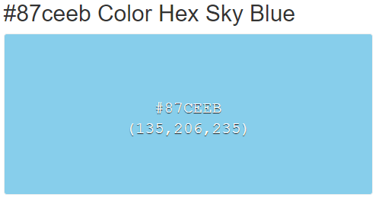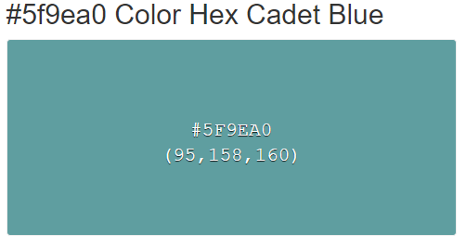After carrying out some research (websites used at the end of the report in section identification of information sourced) I have thought of and came up with the colour scheme of the colour. Blue is a calm colour and is easy on the eye when looking at it or having it as a background for text. I have made sure to keep the scheme of blue throughout the website and made sure not to contrast any colours that may affect users that have sight difficulties. I have shown the two main colour that I used down below:

### 3.7.2. Font Choices

For the font of the website, I decided to use a simple and clear font, which was Helvetica, sans-serif. I chose this font as it is very easy to read and understand, as it is nothing fancy. Being a simple font also means that people who have difficulty reading may find it slightly easier to read with the chosen font rather than other types of fonts, for example Comic Sans. An example of heading and body text of the font are shown below:

## 3.7. Prototype Description

In this section I will be discussing in detail what the prototype contains and the missing information and features that are currently not included in the website due to it being a prototype version. I have already covered a lot about the what each page includes and missing elements and features in section: *3.2. Wireframes, Content and Media Elements*.

### 3.7.1. Included Features and Elements

My prototype type follows the design and layout created with wireframes, I have achieved implementing all the media elements that Intended and made sure they all work correctly.

On every page of the website, I have managed to display menus that link to all other pages of the website. I wanted to have this feature implemented into my website because it creates a huge shortcut to navigate the website a lot quicker rather than have to go through page after page to find the required page. Another feature that is available throughout the website is an animation with the header logo turning into a home button with a mouse over effect. I added this feature in because it keeps the website clean by not displaying another button along with the links. It also creates a small animation which can be eye catching when hovering over.

A big feature that I manage to implement on the homepage using JavaScript was an image viewer using different buttons, each button displays a different image. I added this functionality to allow the user to view images of the GIMP program with ease and including it on the homepage means that the user I going to see it straight away when they access the website. Another element I was able to embed into the site was a video. The reason I added a video is to give the user an option of how they would like to learn about GIMP, they can either read about or watch the short video.

### 3.7.1. Features and Elements not Included

I managed to create and implement most features and pages into the prototype but not all. I decided that some features and pages would not need be shown right away and would be completed in later iterations of the development. I have added small messages throughout the website to show where features and content are missing.

I decided to create both additional pages for tutorials, intermediate walkthroughs and complex tasks, these two pages are full functional with working external and internal links to other pages of the website. Even though the pages work correctly and display, they do not contain any information or tutorial like I proposed to do. I have done this because I have created a tutorial on the beginner’s tutorial page which shows a prime example of what all other tutorials will look like on all three pages. I only created the one tutorial as I feel as though I gives you a good idea of how I will layout tutorials at all levels in the completed development.

Another development choice I chose was to create the hints and tool tips back and have that also fully functional, but it does not contain any content. I have shown what the page will look like through wireframes and design plans, but I decided not to add ant content on this page as I feel as though the layout of the page would not be much different to the others. There would only be some text and lists displayed which can be shown and described by a wireframe diagram.

Throughout the website, all menus are accessible and display all pages that can be accessed, but with some pages not fully complete and not all tutorials accessible at the current time, I have temporarily displayed a coming soon message to show where a link will be located. My choice in not have all links in the menus functional was because I have already used a lot of links and feel as though they give you a good idea of what the menus will look like in the final version of the website.

All missing content and features will all be finished and functional in the final design.

# 4. Testing

For testing, I attended the lab and achieved getting both marks checked off.

## 4.1. Usability Test

I created a list of tasks and a small questionnaire for users to carryout which can be found in the document: **GIMP Help Site - Testing Tasks and Questionnaire**.

A completed version from a user can also be found in the file: **GIMP Help Site – Completed Testing Tasks and Questionnaire**.

## 4.2. Test Plan

I created a test plan on how I am going to be testing the functionality of the website with test tables for each page containing the purpose of the test and the action performed to test the function. The document: **GIMP Help Site – Test Plan** contains the test plan used on the website.

## 4.3. Test Runs

After carrying out the test plan, I created another document: **GIMP Help Site – Test Runs** and documented all the results of the tests.

5. Identification of Information Sourced

|  |  |
| --- | --- |
| [1] | Neilpatel, “neilpatel.com - How to Use the Psychology of Color to Increase Website Conversion,” 2019. [Online]. Available: https://neilpatel.com/blog/psychology-of-color-and-conversions/. [Accessed 24 10 2019]. |
| [2] | GIMP, “gimp.org - GIMP GNU Image Manipulation Program,” 2019. [Online]. Available: https://www.gimp.org/. [Accessed 24 10 2019]. |
| [3] | w3schools, “w3schools.com - W3Schhols Online Web Tutorials,” 2019. [Online]. Available: https://www.w3schools.com/. [Accessed 24 10 2019]. |
| [4] | S. Overflow, “stackoverflow.com - Where Developers Learn, Share & Build Careers,” 2019. [Online]. Available: https://stackoverflow.com/. [Accessed 28 10 2019]. |
| [5] | I. D. Foundation, “intercation-design.org - Schneiderman's Eight Golden Rules Will Help You Design Better Interfaces,” 2019. [Online]. Available: https://www.interaction-design.org/literature/article/shneiderman-s-eight-golden-rules-will-help-you-design-better-interfaces. [Accessed 28 10 2019]. |
| [6] | M. Batagoda, “uxplanet.com - Usability for Designers, P-A-C-T Framework,” 2018. [Online]. Available: https://uxplanet.org/usability-for-designers-p-a-c-t-framework-20509afcff57. [Accessed 30 10 2019]. |
| [7] | Moqups, “moqups.com - Online Mockups, Wireframe & UI Prototyping Tool,” 2019. [Online]. Available: https://moqups.com/. [Accessed 30 10 2019]. |